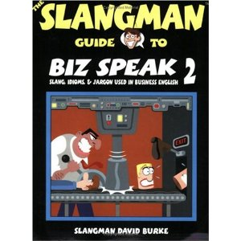
Advanced Business English Studies
Slangman guide to Biz Speak 1, 2 and 3by David Burke
Now you can hear how natives speak! Because Americans shorten and combine words when they speak in everyday conversations, understanding them can be extremely difficult...but there is help!
You need to know how English really sounds and get used to the speed!
Each audio product contains "real speak" versions of the dialogues and vocabulary. "Real speak" features the shortened or "real" pronunciation Americans use every day. If you want to feel comfortable speaking with Americans and understanding conversations in English, these audio products are essential.
Listen to these audio products and you will be ready to hear English, understand English, and use English!
Don't be confused or embarrassed when doing business with Americans! Entertaining dialogues, activities, and games will help you understand the real language spoken in American businesses. The Slangman Guide to Biz Speak books are so popular, they are being used by business professionals around the world.
Our books contain the most common slang and idioms used every day by Americans. Look at this example:
English taught in schools: "My plane leaves New York late at night and arrives in Paris early the next morning."
Real American English: "I am taking a red-eye from New York to Paris."
Both of them mean the same thing, but "Real American English" is the way Americans speak. With our books, you will learn American English conversation using slang and idioms naturally through dialogues, pictures, quizzes, games, etc.

